Use 7zip,

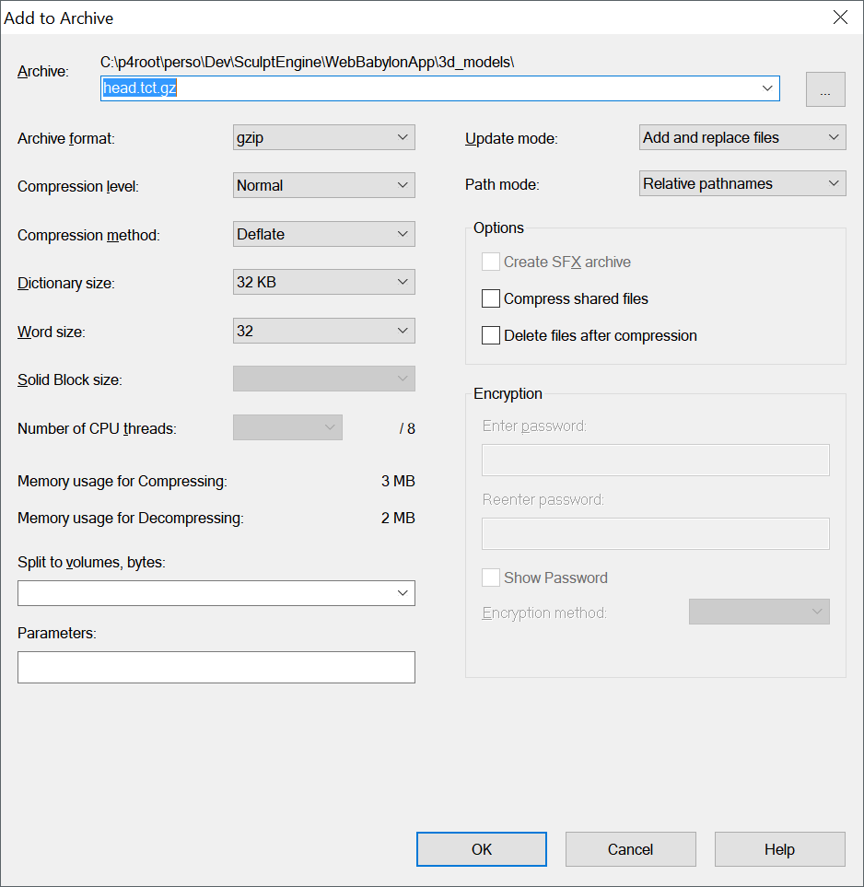

Remove gz extension.

Upload to amazon S3 (and switch it to public)

Set meta data like this:

